
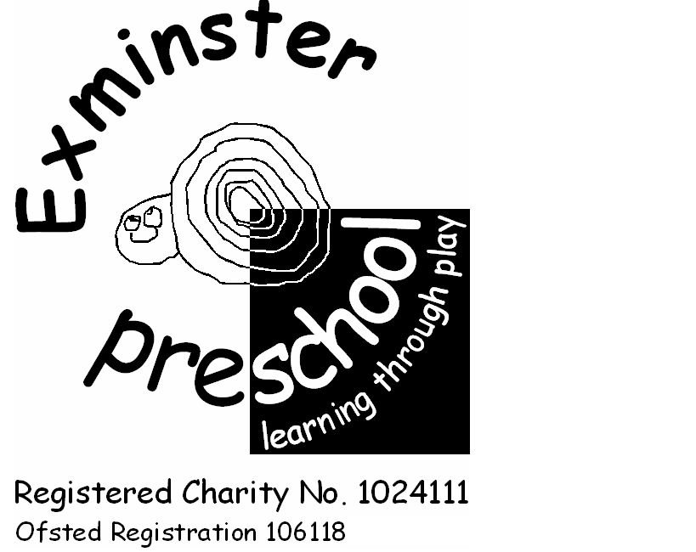
Registration Form Exminster Pre-school

Please return this form to Leah Barnes Pre-school Manager:
By email: info@exminsterpreschool.co.uk
By post: 12 Aboveway, Exminster, EX6 8DT
By hand: Deepway Centre, Deepway Lane, Exminster (9 -3.15p.m, Friday 9 – 3.15.p.m Term-time only)

Child’s Name |  |  |  | Date of Birth
Parent’s Names
Address
 |  |  |  | Postcode
Telephone |  | Email

I / We wish to apply to join Exminster Pre-school
❑ As soon as possible ❑ From ___________________ (date)

Please indicate all session(s) you require |  | Mon | Tue | Wed | Thu | Fri
08:00 – 09:00 | Breakfast Club
09:00 – 12:00 | Morning
12:00-13:00 | Lunch
13:00-15.15 | Afternoon
15:15-16:00 | Extended Afternoon |  |  |  |  | Closed
16:00 -17:00 | After School club |  |  |  |  | Closed

Charges

Under 3’s: £6.45 per hour Over 3’s: £5 per hour We offer 15 & 30 hour free entitlement

This application places your child on our waiting list and we will contact you as soon as possible to confirm a place. Please note that completion of this form does not guarantee a place for your child.
Once your child’s place has been accept we will need to ask for further personal information and family details for our admission records. We will also need to see your child’s birth certificate at this point. Any details we gather from you will be protected in accordance with our Data Protection and Privacy policy.
If you find that you no longer need the place, please inform us as soon as possible. Should you decide you no longer need the place, we will not retain your details on this application form (please see our Privacy Policy).

Signature of Parent/Carer Date

For completion by Exminster Pre-school

Leah Barnes Pre-school Manager: 12 Aboveway, Exminster, EX6 8DT. Tel 832348
Pre-school: Deepway Centre, Deepway Lane, Exminster (9 – 3.15, Friday 9 – 3.15.p.m - Term Time only) Tel. 833320
Email: leahbarnes@exminsterpreschool.co.uk

______________________ will be placed on our waiting list.

You will receive confirmation of a place and your sessions the term before your child’s start date.

Signed for the Pre-school Date

Name Title

